Basic Injury Management

1. PREVENTION Try to stay injury free by appropriate strength and conditioning training. Always do dynamic stretching before and after training. Ensure adequate REHYDRATION after every session.
2. REST Keep the injured area supported and still for the first 24 hours, then gradually and gently introduce movement over the next 48 hours. It is not advisable to “push through pain” or try to “play it off”.

3. ICE Apply ice to the area for 10-15 minutes every 2-3 hours in the first 72 hours.

4. COMPRESSION Apply a gentle compression support to the area.

5. ELEVATION Elevate when possible to minimise swelling.

6. REHABILITATION Most simple injuries should repair naturally, but appropriate rehabilitation exercises help to ensure effective recovery and reduce the risk of re-injury as fitness and stability is regained.

If an injury persists then seek professional medical advice.

Seek immediate medical attention if any of the following occur:

- Head, back or neck pain
- Nausea, vomiting, dizziness or visual disturbance
- Pins and needles or numbness
- Inability to bear weight

Sports Injuries

Common causes of sports injuries are:

- Inadequate and/or inappropriate preparation for sport. Warm up and cool down phases are essential to influence blood flow, flexibility and minimise post exercise stiffness.
- Too much training or repetitive activities.
- Improper equipment e.g. footwear.
- Poor technique.
- Collision/contact.
- Returning to sport too soon following an injury or inadequate rehabilitation post injury.

Chartered Physiotherapists are experts in body movement. They will be able to diagnose the problem, relieve the symptoms, promote healing and recovery and work with you to develop an effective treatment programme to facilitate an efficient rehabilitation.
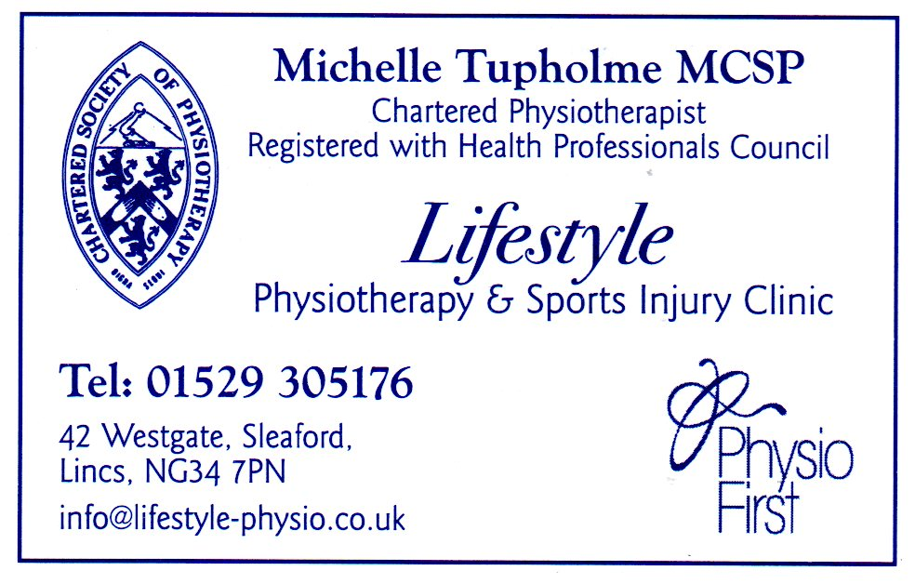
Supporting Sport: Supporting You to Play!

